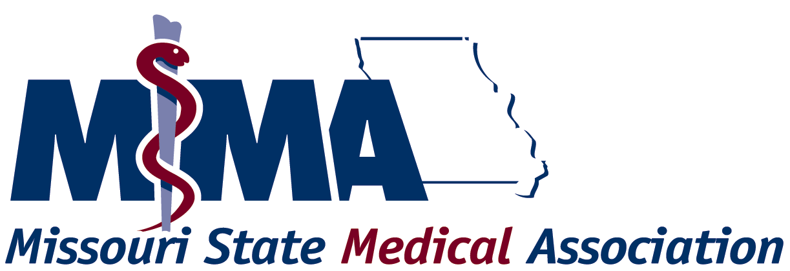

The MSMA values the feedback it receives from providers regarding its processes. Please take time to provide feedback to the MSMA by completing this evaluation form. Upon completion, please e-mail this form directly to bstennis@msma.org. If you have questions regarding this evaluation, phone us at 573/636-5151.

Your ACCME Provider Number |  |  |  |  |  | Survey Date
Your Organization Name
Your Name
Your Telephone Number |  |  |  |  |  | Your e-mail Address
Initial Applicants ONLY |  |  |  |  |  | Applicants for re-accreditation ONLY
 |  |  |  | YES | NO |  |  |  |  | YES |  | NO
1 | Was the information contained in the pre-application package adequate to help you decide whether to seek accreditation? |  |  |  |  | 7 | Did you receive adequate notice of your need to apply for re-accreditation?
2 | If no, please comment: |  |  |  |  | 8 | If no, please comment:
3 | Was the review of your pre-application and communication of the results of this review completed in a timely manner? |  |  |  |  | 9 | Were the instructions for completing the self-study sufficient to guide you through the process?
4 | If no, please comment: |  |  |  |  | 10 | If no, please comment:
5 | Were the instructions for completing the application sufficient to guide you through the process?
6 | If no, please comment:
11 | Check here if you did not contact MSMA staff for assistance in completing the application or self-study, and proceed to question 14.
12 | When you contacted MSMA staff for assistance in completing the application or self-study, were you satisfied with the assistance you received?
13 | If no, please comment:
14 | Please provide us with your comments (positive and constructive) regarding the pre-survey application and self-study process:

All Applicants…the Survey
Scheduling: |  |  |  |  |  |  |  |  |  | YES |  | NO
15 |  | Was the agenda for the day reflective of the actual interview?
16 |  | Were you given notice of the date and time of your survey in a timely manner?
17 |  | If no, please comment:
18 |  | Did the Chair of the survey team contact you at least one month prior to the survey to establish an agenda for the interview?

19 | Was the time allotted for your survey adequate?
20 | If no, please comment:
21 | Please provide us with your comments (positive and constructive) regarding the scheduling of the survey:
Conduct of the Survey:
22 | During the conduct of the survey, how would you describe the overall tone set by the survey team?
 |  |  |  | YES | NO
23 | Did you have adequate opportunity to present information about your program to the survey team?
24 | If no, please comment:
25 | Did the survey team inform you of when a decision would be made on the status of your application or self-study?
 |  | Chair |  | Co-Chair
 | Surveyor Names:
 |  | YES | NO | YES | NO
26-27 | The surveyor was familiar with my application.
28-29 | The surveyor was knowledgeable about the requirements of the ACCME’s Essential Areas, Elements, and accreditation policies.
30-31 | The surveyor had adequate knowledge about the accreditation process.
32-33 | The surveyor was complete and thorough in the review of my overall program.
34-35 | The surveyor maintained professional decorum throughout the survey.
36-37 | The surveyor disclosed when he/she provided advice or personal opinion during the survey.
38 | Comments regarding the Chair of the survey team:
39 | Comments regarding the Co-Chair:
40 | Comments regarding the overall conduct of the survey:
All Applicants…. Overall Evaluation: |  |  |  | YES | NO
41 | Do you believe that the application/self-study and survey processes have been effective means for gathering accurate and complete data about your overall CME program’s compliance with MSMA’s Essential Areas, Elements, and accreditation policies?
42 | If no, please explain the source of weakness:
43 | Please provide us with any additional feedback you have regarding the accreditation process:

