Date

Dear:

Thank you for your offer to provide funding, in the form of an unrestricted educational grant for the Missouri State Medical Association’s 144th Convention. Your financial support is greatly appreciated. MSMA will acknowledge your support in our program materials and by announcement where appropriate.

As an accredited provider of CME, it is our responsibility to ensure that all aspects of the CME activity comply with the Accreditation Council for Continuing Medical Education Standards for Commercial Support of Continuing Medical Education. In brief, this means that we will assume responsibility for all administrative and educational responsibilities to develop and evaluate this program. The Standards for Commercial Support are enclosed for your review.

As part of our compliance we will provide you, upon request, a full accounting of how the educational grant was dispersed. It is further understood that no additional funds, in the form of honorarium expenses, gifts, etc. will be provided by you to the program faculty over and above that to which you, the MSMA and the faculty have agreed.

As acknowledgment of your agreement to these conditions, please sign the attached agreement in the appropriate space and return it in the enclosed envelope.

Again, thank you for your efforts in helping us provide quality CME to Missouri physicians.

Sincerely,

Benita Stennis
Director of Scientific Affairs

Enclosures

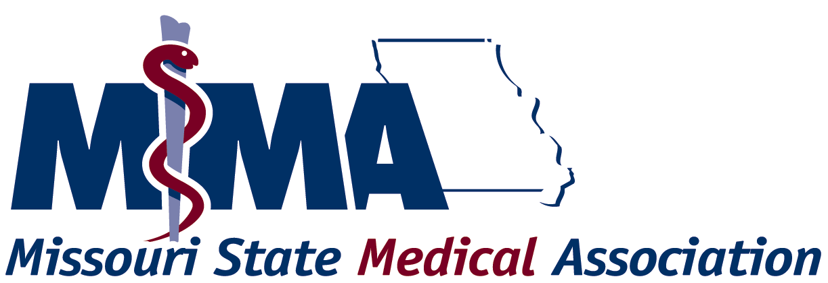
______________________________________________________________________

WRITTEN AGREEMENT FOR COMMERCIAL SUPPORT

MSMA is committed to presenting CME activities that promote improvements or quality in healthcare and are independent of the control of commercial interests. As part of this commitment, MSMA has outlined in this written agreement the terms, conditions, and purposes of commercial support for its CME activities. Commercial Support is defined as financial, or in-kind, contributions given by a commercial interest, which is used to pay all or part of the costs of a CME activity.

Title of CME Activity
Activity Location |  |  |  |  | Activity Date
Name of Commercial Interest
Amount of Educational Grant
(direct or in-kind)
Grant will be used for the following:
Speaker Honoraria |  | Speaker Expenses (itemize) |  | Meeting Expenses (itemize) |  |  | Other (list)

Terms, Conditions, and Purposes

Independence
1. This activity is for scientific and educational purposes only and will not promote any specific proprietary business interest of the Commercial Interest.
2. The Accredited Provider is responsible for all decisions regarding the identification of educational needs, determination of educational objectives, selection and presentation of content, selection of all persons and organizations that will be in a position to control the content of the CME, selection of education methods, and the evaluation of the activity.
Appropriate Use of Commercial Support
3. The Accredited Provider will make all decisions regarding the disposition and disbursement of the funds from the Commercial Interest.
4. The Commercial Interest will not require the Accredited Provider to accept advice or services concerning teachers, authors, or participants or other education matters, including content, as conditions of receiving this grant.
5. All commercial support associated with this activity will be given with the full knowledge and approval of the Accredited Provider. No other payments shall be given to the director of the activity, planning committee members, teachers or authors, joint sponsor, or any others involved with the supported activity.
6. The Accredited Provider will upon request, furnish the Commercial Interest documentation detailing the receipt and expenditure of the commercial support.
Commercial Promotion
7. Product-promotion material or product-specific advertisement of any type is prohibited in or during the CME activity. The juxtaposition of editorial and advertising material on the same products or subjects is not allowed. Live or enduring promotional activities must be kept separate from the CME activity. Promotional materials cannot be displayed or distributed in the education space immediately before, during or after a CME activity. Commercial Interests may not engage in sales or promotional activities while in the space or place of the CME activity.
8. The Commercial Interest may not be the agent providing the CME activity to the learners.
Disclosure
- The Accredited Provider will ensure that the source of support from the Commercial Interest, either direct or “in-kind,” is disclosed to the participants, in program brochures, syllabi, and other program materials, and at the time of the activity. The disclosure will not include the use of a corporate logo, trade name, or product-group message of an ACCME-defined commercial interest.

The Commercial Supporter and
<Insert Accredited Provider Name>
agree to abide by all requirements of the Missouri State Medical Association (MSMA) Standards for Commercial Support of Continuing Medical Education (appended).

Name of Accredited Provider
Tax ID Number |  |  | Email Address
Contact Person |  |  | Fax Number
Phone Number
Educational Partner (if applicable)
Contact Person |  |  | Email Address
Phone Number |  |  | Fax Number
Tax ID Number
Name of Commercial Interest
Address |  |  | Email Address
City, State, Zip |  |  | Fax Number
Contact Person
Phone Number

Agreed by Authorized Representatives

Commercial Interest Accredited Provider

Signature and Date |  | Signature and Date

Print Name |  | Print Name

Title |  | Title

Educational Partner (If applicable)

Signature and Date

Print Name

Title

The MSMA defines a Commercial Interest as any proprietary entity producing health care goods or services, with the exemption of non-profit or government organizations and non-health care related companies. The MSMA does not consider providers of clinical service directly to patients to be commercial interest.

